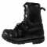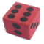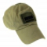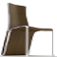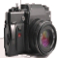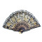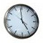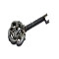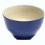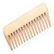
A
C
D
B
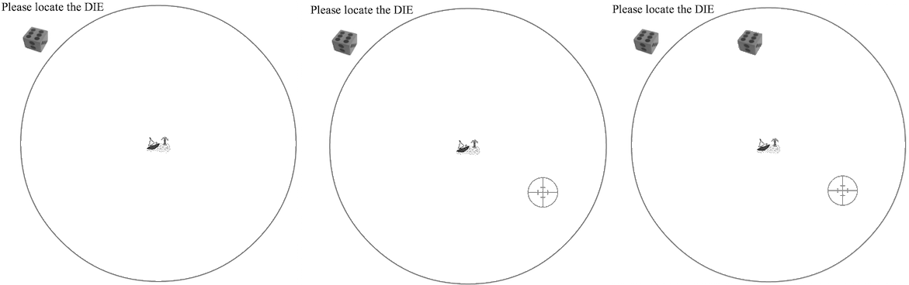
Figure 1. The objects used in Experiments 1, 2 and 3 and an example trial for Experiments 1 and 2. (A) The ten objects used in the visuospatial memory task: boot, die, hat, chair, camera, fan, clock, key, bowl and comb (in the experiment objects were presented in full color). In each trial, (B) subjects were cued to recall the location of the item indicated in the top-left (here: a die). (C) Subjects then clicked a location to respond and a red crosshair marked their selection. (D) During training trials, subjects were then shown the item in its correct location for one second (this feedback was omitted during test trials).

